|  |  |
| --- | --- |
| Table S1 |  |
| *Parameter Population Values for Simulated Examples* | | | |
|  | Constrained | | Freely Estimated |
| Parameter | Example 1 | | Example 2 |
| Univariate M |  | |  |
| $$μ_{x}$$ | 0 | | 0 |
| $$σ_{x}^{2}$$ | 1 | | 1 |
| $$μ_{m0}$$ | 6 | | 6 |
| $$μ_{sm}$$ | 0.9 | | 0.9 |
| $$β_{m}$$ | -0.05 | | -0.05 |
| $$σ_{m0}^{2}$$ | 0.49 | | 0.49 |
| $$σ_{sm}^{2}$$ | 0.01 | | 0.01 |
| $$σ_{e\left(m\right)}^{2}$$ | 0.025 | | 0.025 |
| Univariate Y |  | |  |
| $$μ_{y0}$$ | 7 | | 7 |
| $$μ_{sy}$$ | -0.5 | | -0.5 |
| $$β_{y}$$ | 0.1 | | 0.1 |
| $$σ_{y0}^{2}$$ | 0.36 | | 0.36 |
| $$σ_{sy}^{2}$$ | 0.04 | | 0.04 |
| $$σ_{e\left(y\right)}^{2}$$ | 0.101 | | 0.101 |
| Mediation/Moderation |  | |  |
| $$a_{X_{1}}$$ | -0.4 | | -0.4 |
| $$a_{Z}$$ | 0 | | 0 |
| $$a_{X_{1}Z}$$ | 0.8 | | 0.8 |
| $$b$$ | -0.13 | | - |
| $$b_{3}$$ | - | | -0.23 |
| $$b_{4}$$ | - | | -0.18 |
| $$b_{5}$$ | - | | -0.13 |
| $$b_{6}$$ | - | | -0.08 |
| $$c^{'}$$ | 0.1 | | 0.1 |

## Figure S1

*Moderator path model*

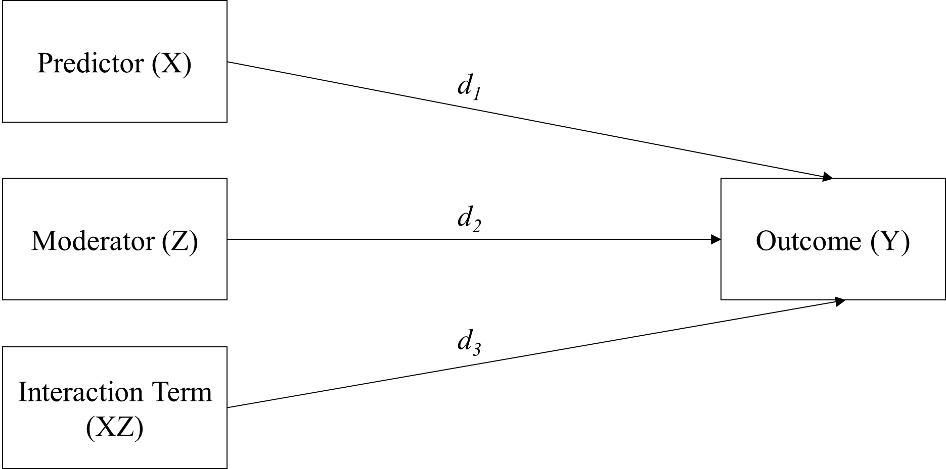

*Note.* Path diagram demonstrating a model including a moderator Z. The *d1* path represents the influence of X on Y controlling for the moderator and interaction term. The *d2* path represents the influence of Z on Y controlling for X and the interaction term. The *d3* path represents the interaction of X and Z predicting Y, controlling for the main effects.

## Figure S2

*Single mediator path model*

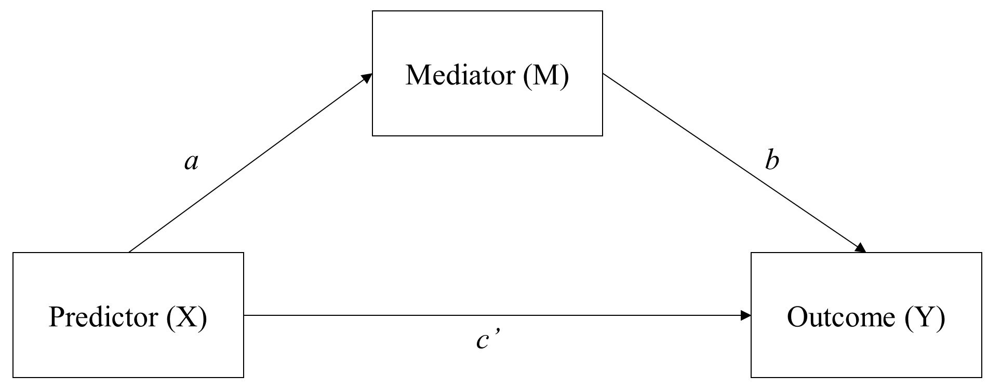

*Note.* Path diagram demonstrating a single mediator model. The *a* path represents the influence of X on M. The *b* path represents the influence of M on Y. The *c’* path represents the direct effect, or the independent variable predicting the dependent variable controlling for the mediator.

## Figure S3

*Single Mediator Model with First Stage Moderated Mediation*

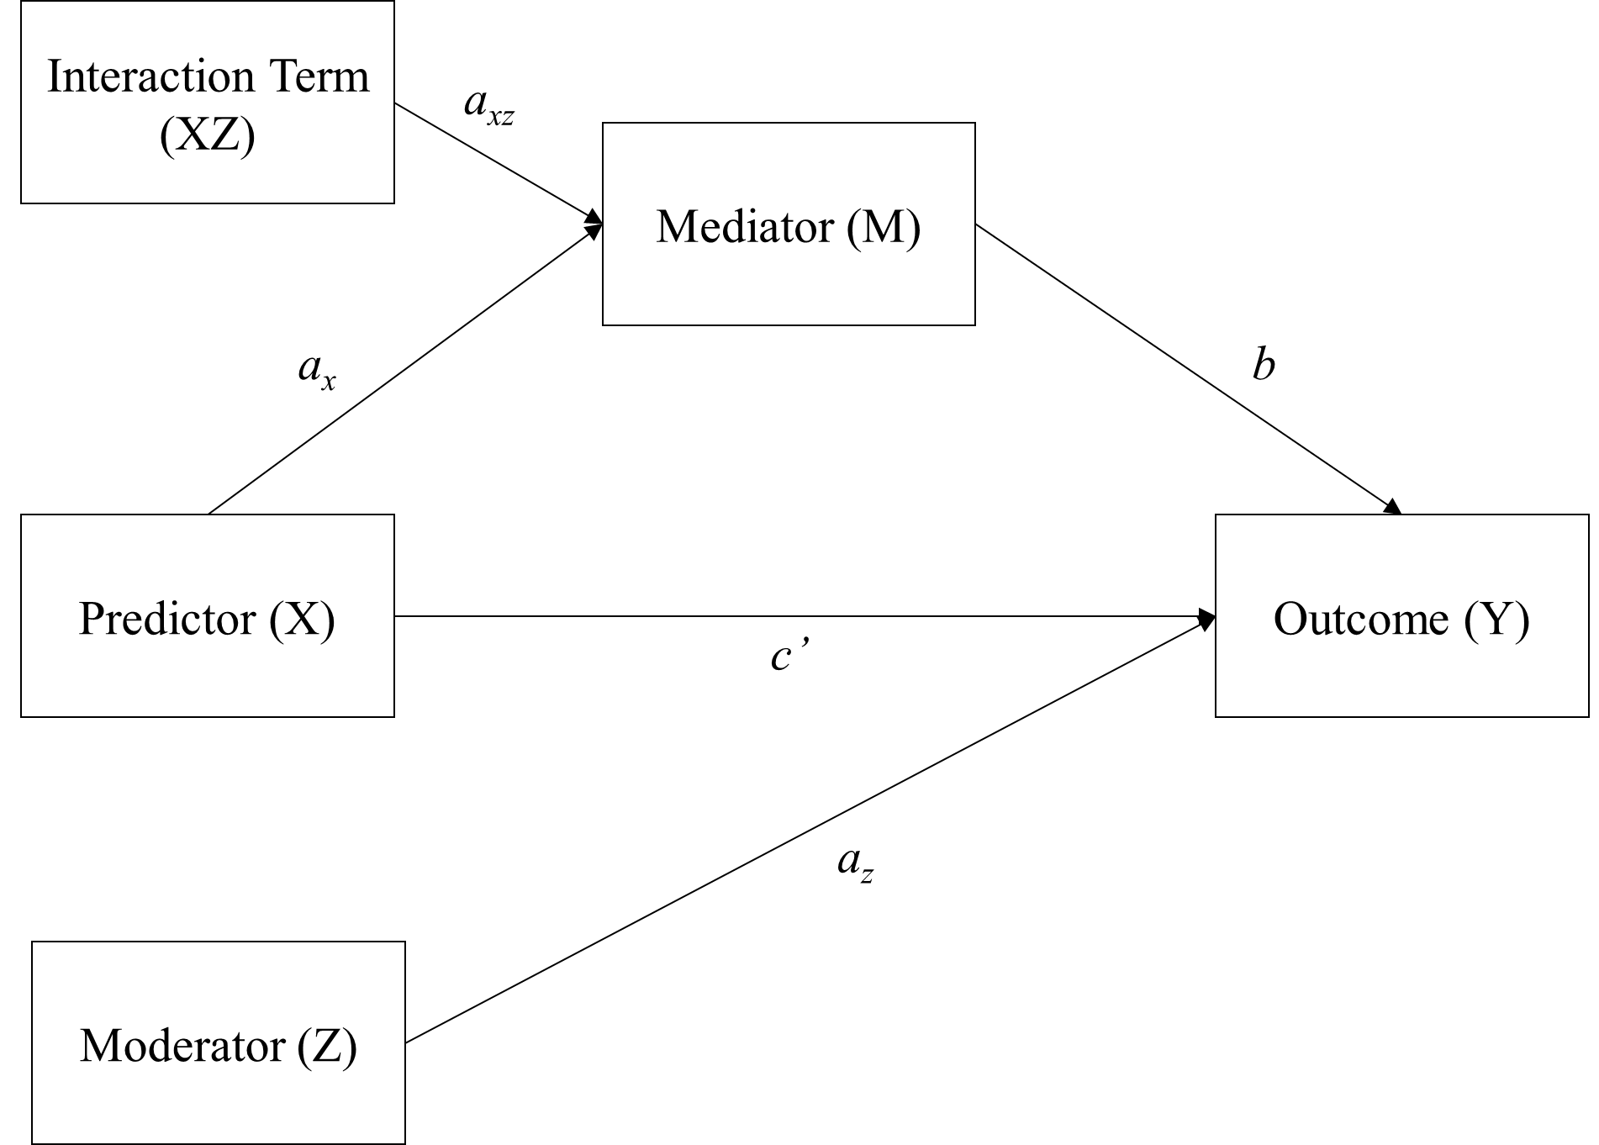

*Note.* Path diagram demonstrating a single mediator model with an additional moderator. Theinteraction term *axz* represents the extent to which the effect of X on M (*ax*) differs across values of Z.